IoT Lab 4

**Name:** Cao Xinyang

**HDU Number:** 20321308

**My Photo:**



**Job issue for the work:**

1. Use the built at the previous classes model of the transport network.

2. Add Pedestrians sources and destinations. They should be separated at least by two roads.

3. Define the areas dedicated to pedestrians.

4. Define the road crossings (at least 2).

5. Create pedestrians' traffic lights.

6. Experiment with social distancing by the pedestrians. The results must be the pedestrians area throughput. What is a realistic social distance in a particular site?

**Model with traffic lights and pedestrians:**

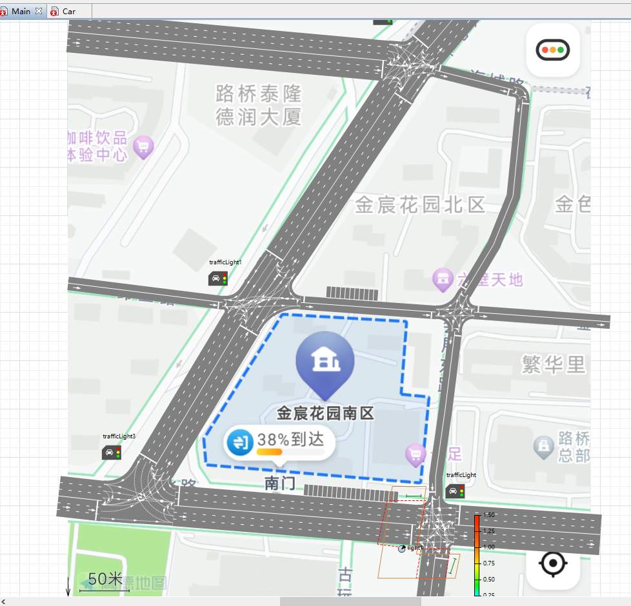 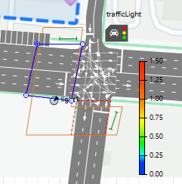

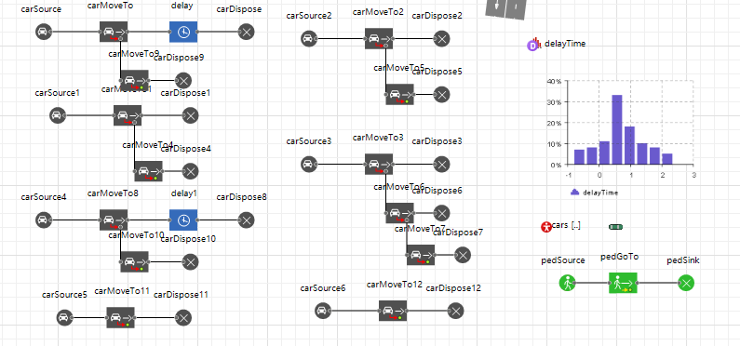

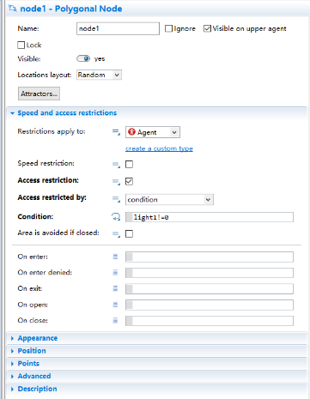 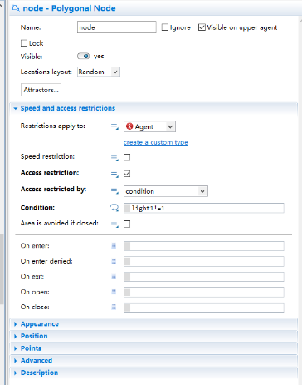 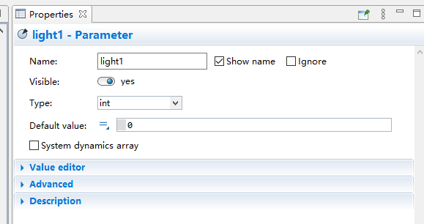

**Run time:**

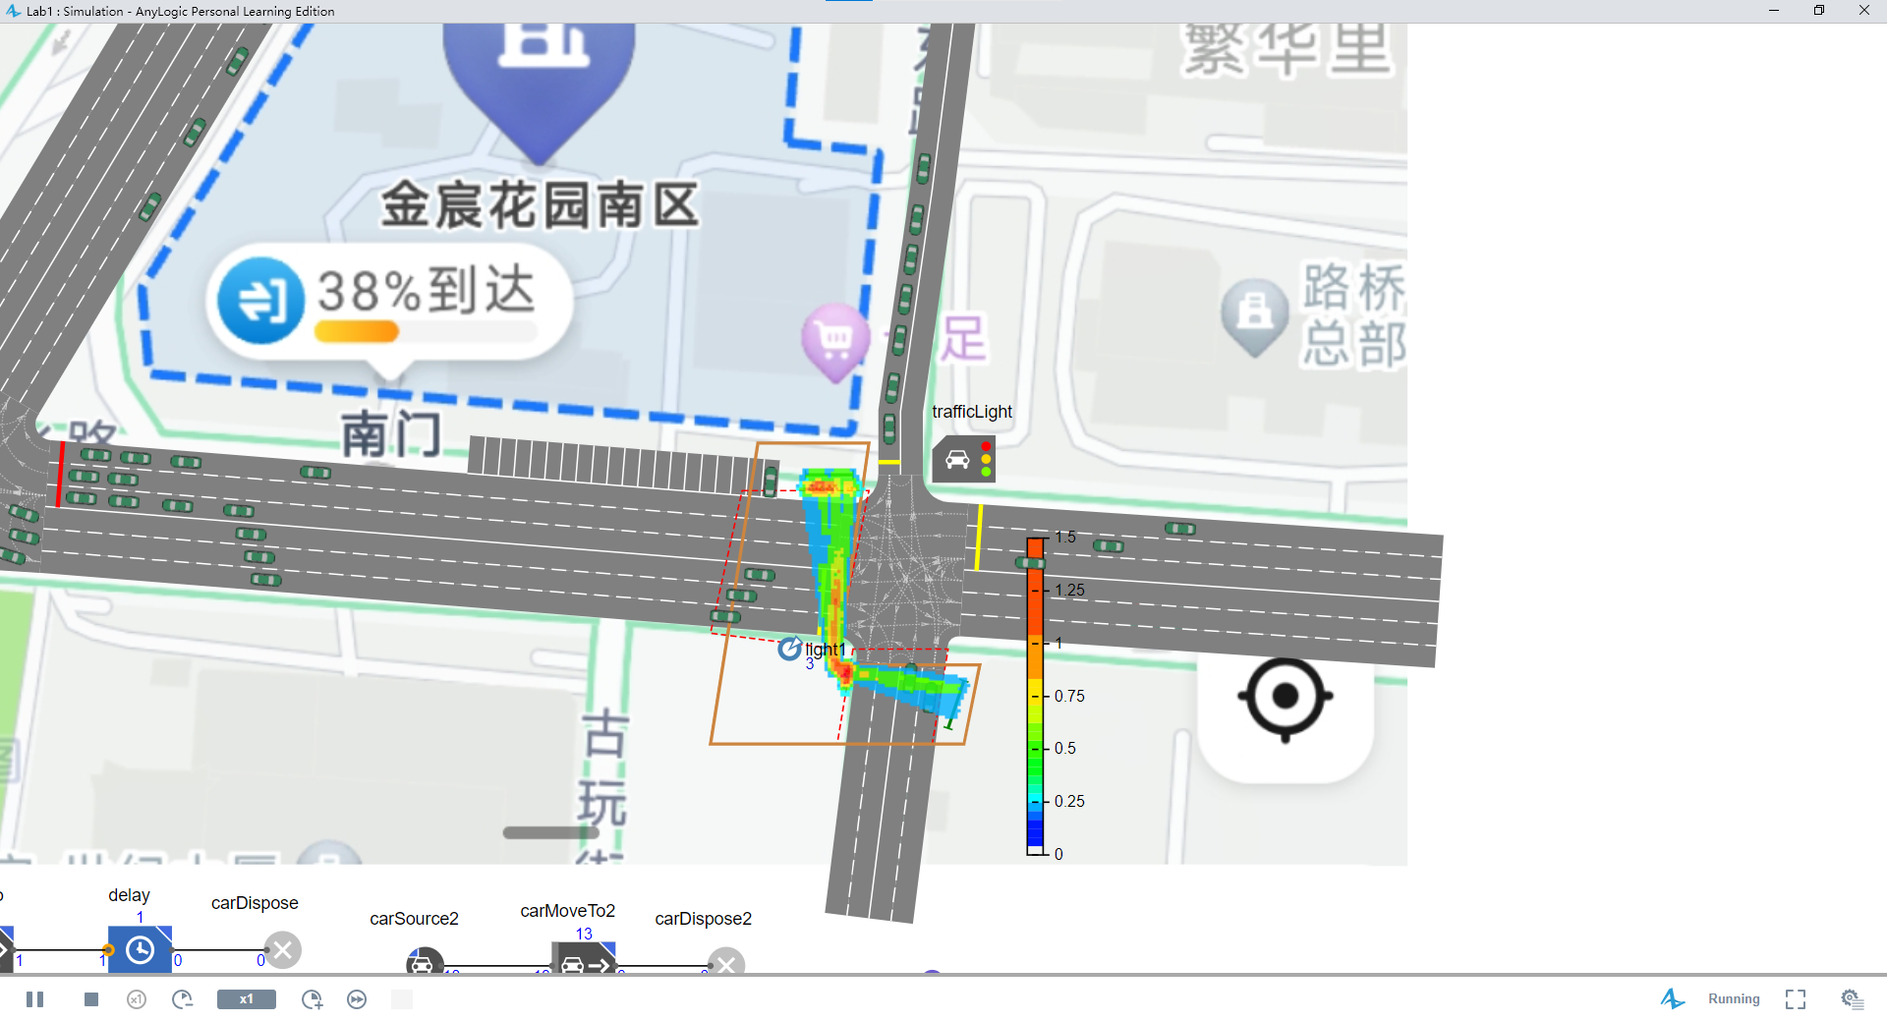

**Parameters and its function:**

**pedSource: A place where pedestrians start**

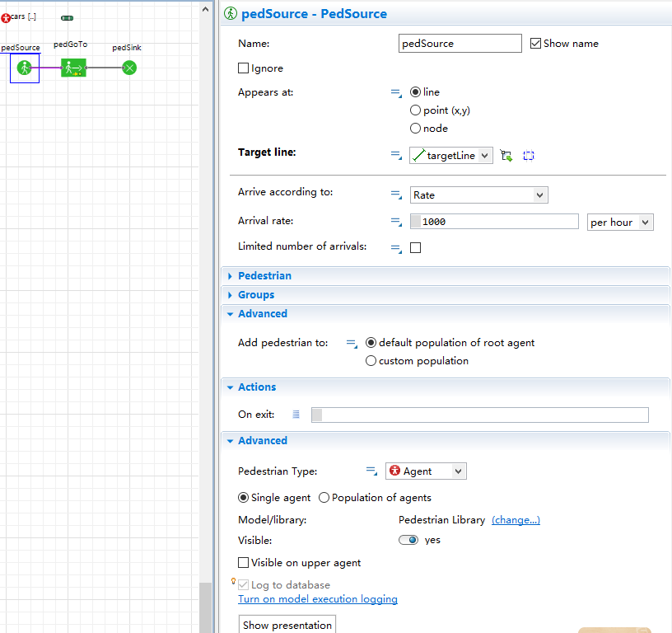

Target line: Set the starting position of pedestrians

**pedGoTo: Set up pedestrian arrivals position**

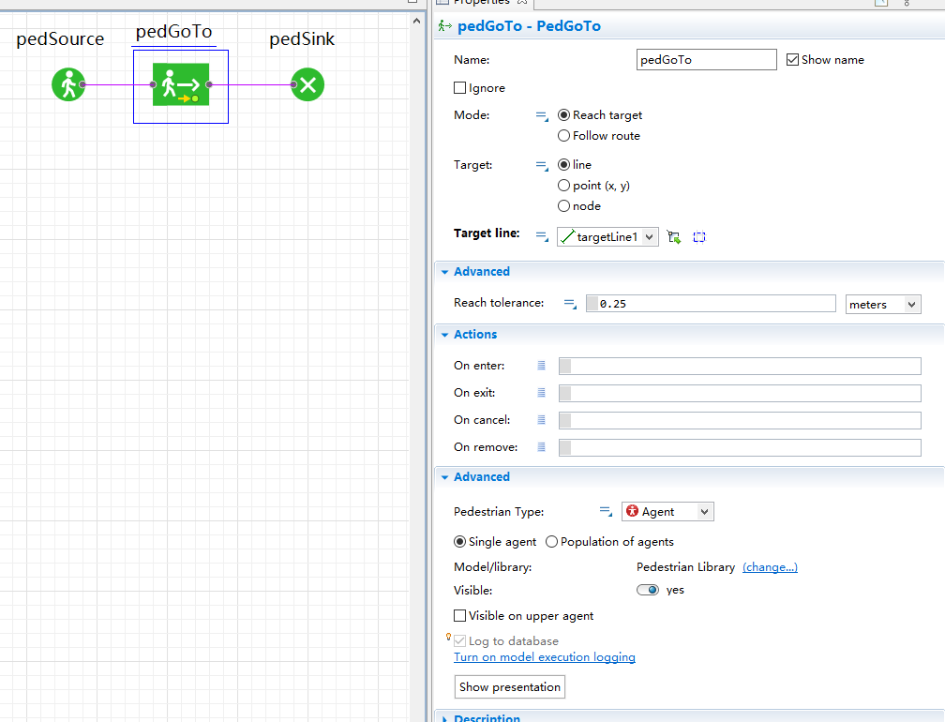

Target line: Set the ending position of pedestrians

**pedSink: Pedestrian elimination**

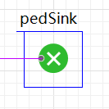

**Wall: Limit the movement of pedestrians**

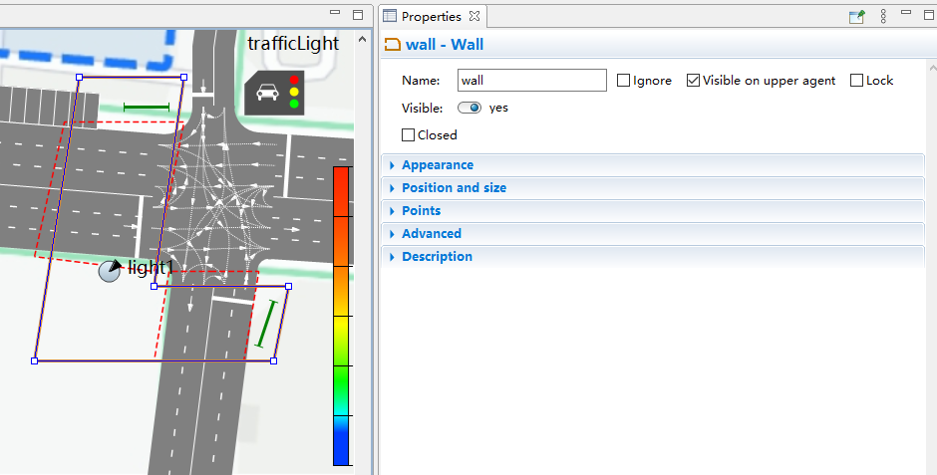

**Polygonal Node: Plan a restricted area**

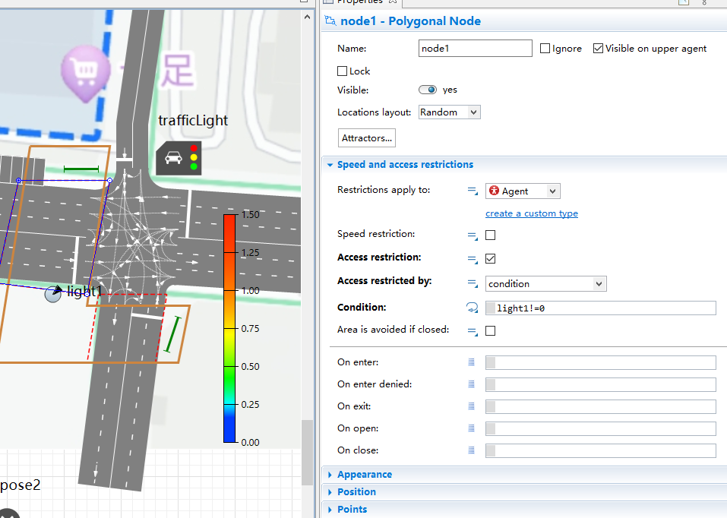

Access restriction: Set up conditions that restrict access

Condition: Conditions restricting access

**Parameter:**



**densityMap: Display pedestrian density information**

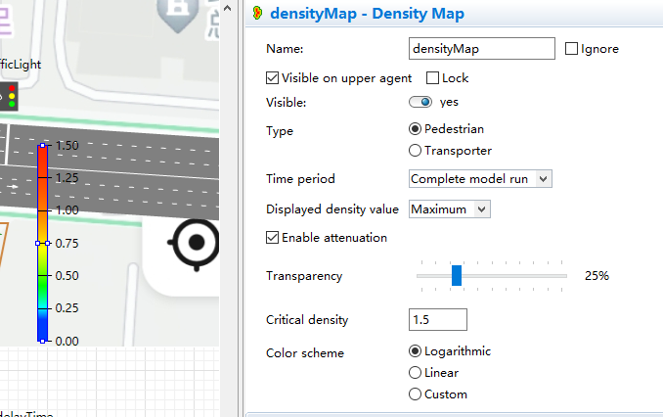

**Conclusion:**

In this task, based on the original model, we created a pedestrian traffic light and linked it to the traffic lights of cars, so that pedestrians can cross the road smoothly when there is no traffic. At the same time, we use density map to display the density information of pedestrians.